The CTF challenge this writeup is for is the YouTube adventure
Firstly, we start with a YouTube link https://www.youtube.com/watch?v=wKz32opINzo, which is titled “quest1”. There is a text in the video asking us to help the person find the flag. The subtitles show the next YouTube link. Afterward, there is a maze in the video, and the description has a placeholder text hiding the real clue.
Red: qxU
Orange: bUB
Yellow: sGd
Green: bPA
Blue: mrT
Purple: MTa
Pink: Q==
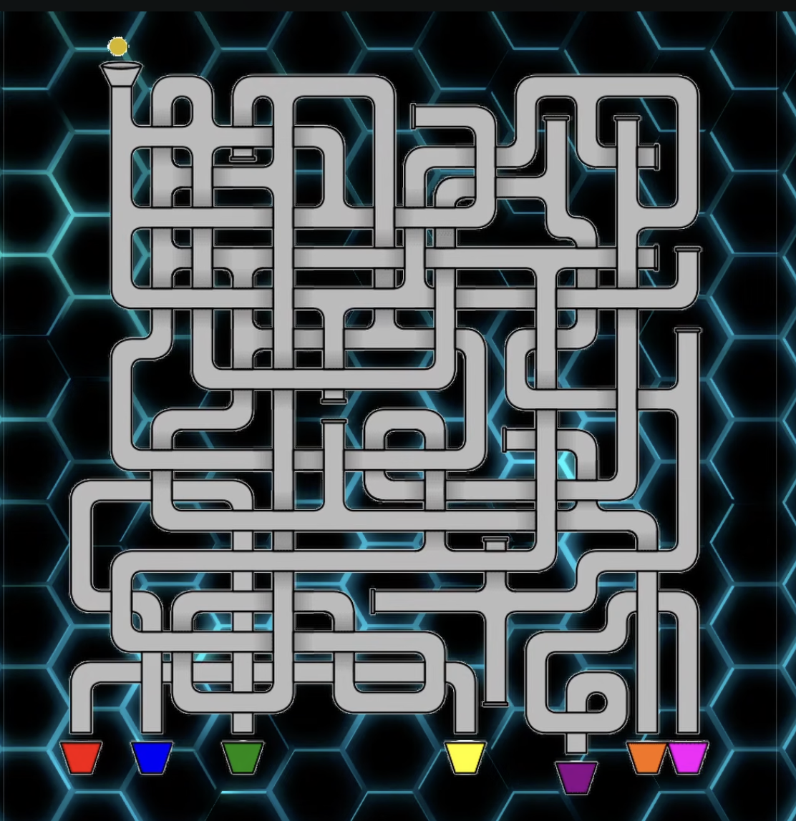
But we will save this for later.
The next video https://www.youtube.com/watch?v=p1OGNSLqnZI named “quest 2” shows the seven YouTube links below:
https://www.youtube.com/watch?v=7FwDP17XPlk, which is just Rick Astely’s Never Gonna Give You Up,
https://www.youtube.com/watch?v=S8enYup_FaY, which is the 2026 MIT Integration Bee – Final
https://www.youtube.com/watch?v=Vjf_5VHYy3w, which is the next video quest3
https://www.youtube.com/watch?v=vFTeN17Z4rc, which is the 2017 Raytheon MATHCOUNTS National Competition
https://www.youtube.com/watch?v=tSBWmxwT8So, which is Tears For Fear’s Everybody Wants To Rule The World
https://www.youtube.com/watch?v=u0Akq3fGknE, which is LITCTF 2023 | Web Writeup | My boss left, unsecure, Ping Pong
https://www.youtube.com/watch?v=Mi6RqGP7yJM, which is MITIT 2025-2026 Winter Contest Closing Ceremony.
Despite finding the next video link, we still need to check if there is more stuff we might have missed that lead us to the flag, in the subtitles there are two subtitles one that shows a normal message the second showing a jumble of letters saying TdD.
In quest 3 https://www.youtube.com/watch?v=Vjf_5VHYy3w, we see a 10 second glitch screen. The link of the next quest is hidden at the bottom of the description, at 7 seconds a part of the screen darkens and shows NyM, which will be used later.
At quest4 https://www.youtube.com/watch?v=znqPQdxS_8U, we see an action movie like 5 second montage, the next YouTube link is hidden in the thumbnail. There is also a comment saying “Tax”, which is important later.
In quest 5 https://www.youtube.com/watch?v=bZjgdbGZIEM, it contained morse code which could be decipher using a morse code decoder (this is the one I used: https://morsecode.world/international/decoder/audio-decoder-adaptive.html). This gave us the next YouTube link. At 15 seconds we also see the code “fQ” which is important later.
Quest 6 https://www.youtube.com/watch?v=R3x8SMCUQzk, shows us some text saying we found the last video, but the flag was split in half and was separated within the videos. The first half was LITCTF {y0uTuB3, and we see “==” which is displayed in the last part of the video.
In the first video, by tracing the input and exit of the maze, we discovered that the only exit is the orange cup. None of the other cup-exists have a path towards the entrance of the maze. This means that the orange cup is the correct color, which infers the code bUB. By adding all the code we got from the six videos, we get bUBTdDNyMTAxfQ==, which is a base64 encoding. After using this tool, which is helpful especially for multiple layer encryption: https://gchq.github.io/CyberChef/#oeol=FF, the code is translated into m@St3r101}. This is the last part of the flag, combining all we had together, the flag is LITCTF{y0uTuB3m@St3r101}.

